<Code> Quiz

1. Please write the word that contains the longest dash occurrences in a row in Morse code. [ 5 points]

For example: GOD = --. --- -.. The number of the longest dash occurrences in a row is 4.

Answer: bottommost

1. Please write the word that contains the longest dot occurrences in a row in Morse code. [ 5 points]

Answer: Mississippian Mississippi

1. Please write a program (in any language you like) to detect the longest occurrences of dash/dot in a row in the Morse code of the given word. [5 points]

Answer: See MorseCode.py

1. What is the equivalent resistance between A and B, given R1=100 Ohm, R2=100 Ohm, R3=100 Ohm, R4=200 Ohm and R5 = 200 Ohm [5 points]

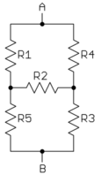

Answer: 140 Ohm, see ResistanceCalculation.py

1. What were the first words transmitted by the electric telegraph in 1844? Please translate the whole paragraph where the words from to Chinese. And what the distance between the sender and receiver when these words were transmitted? For how much Professor Morse sold his telegraph patent to the U.S. government and what is the net present value of that money? [2 points]
2. If a dog is trained to carry three 8mm cassette tapes running in a speed of 18km/s from A to B, each tap contains 7GB data, at what distance that the dog data transporting speed is 54Mb/s? [2 points]
3. Translate the barcode below



1. (626.2）10=（       ）3  （Roundup to the forth place） [2 points]
2. What are the symbols for AND OR NOR NAND EXOR EXNOR logic gates? Please also writhe down their truth table. [2 points]
3. What is the output of the circuit? [2 points]

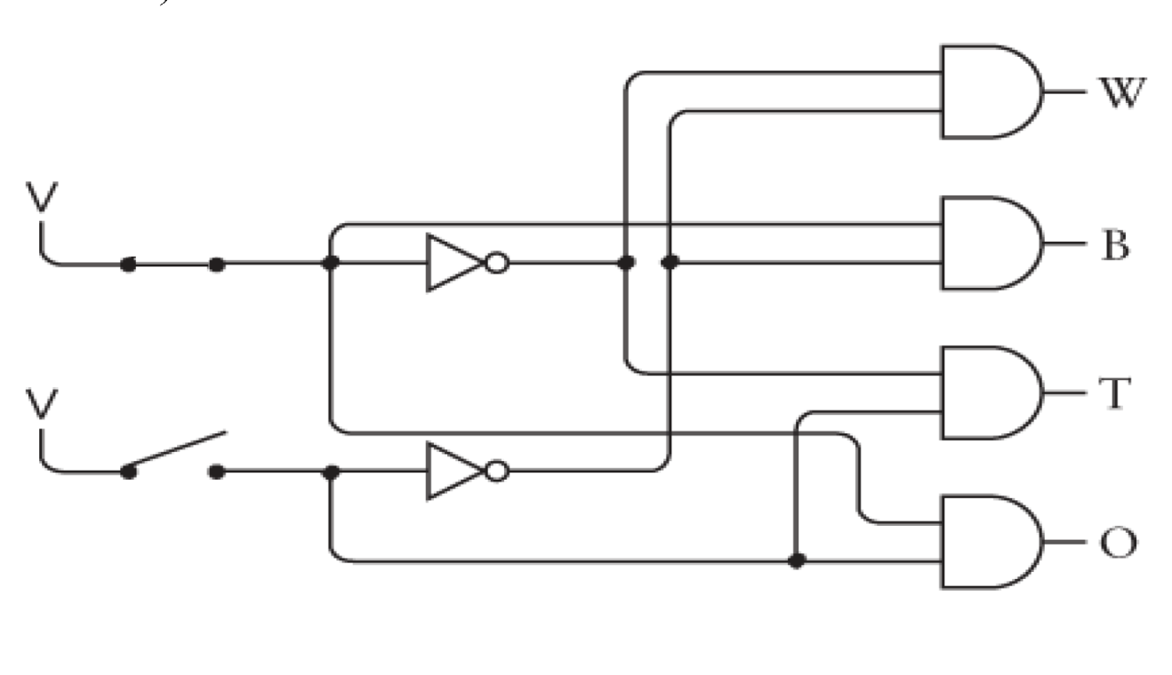

Answer: B

1. Please complete the truth table for the ‘full adder’[2 points]

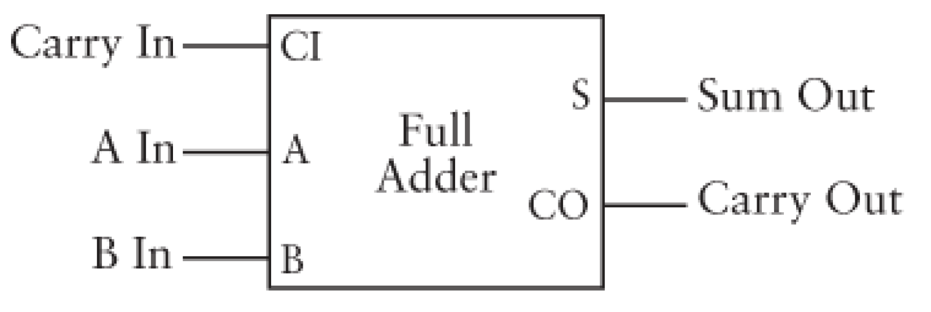

|  |  |  |  |  |
| --- | --- | --- | --- | --- |
| A In | B In | Carry In | Sum Out | Carry Out |
|  |  |  |  |  |
|  |  |  |  |  |
|  |  |  |  |  |
|  |  |  |  |  |
|  |  |  |  |  |
|  |  |  |  |  |
|  |  |  |  |  |
|  |  |  |  |  |

1. At least how many digits are required in binary number to represent a decimal number with 4 digits? [2 points]
2. When $S_{0}=1,S_{1}=0,S_{2}=1$, the output equals to which data in? [2 points]

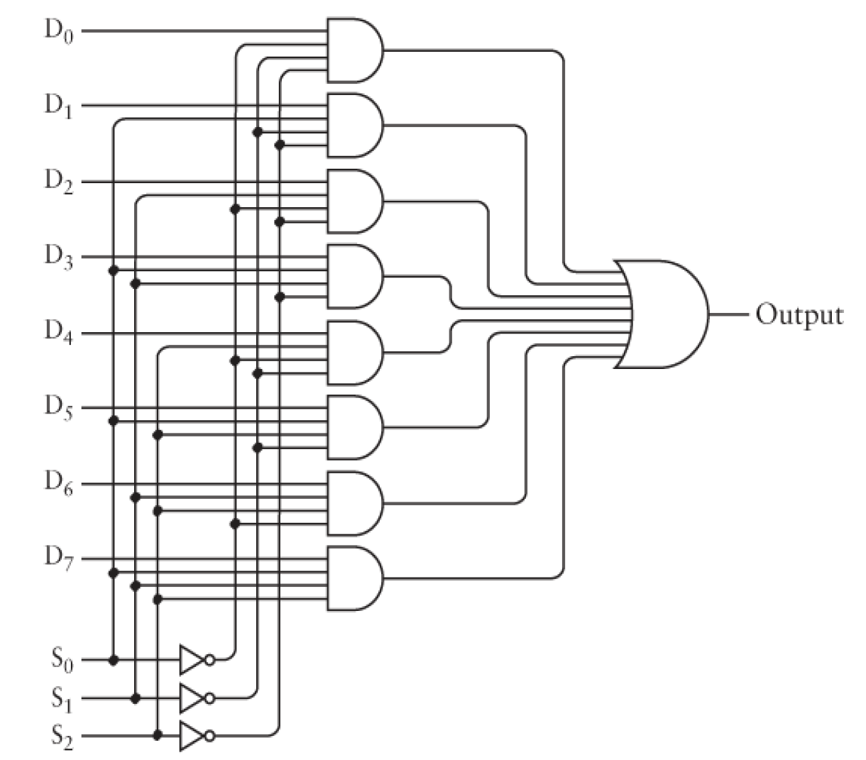

1. When $S_{0}=1,S_{1}=0,S_{2}=1$, which data output equals to the data in? [2 points]

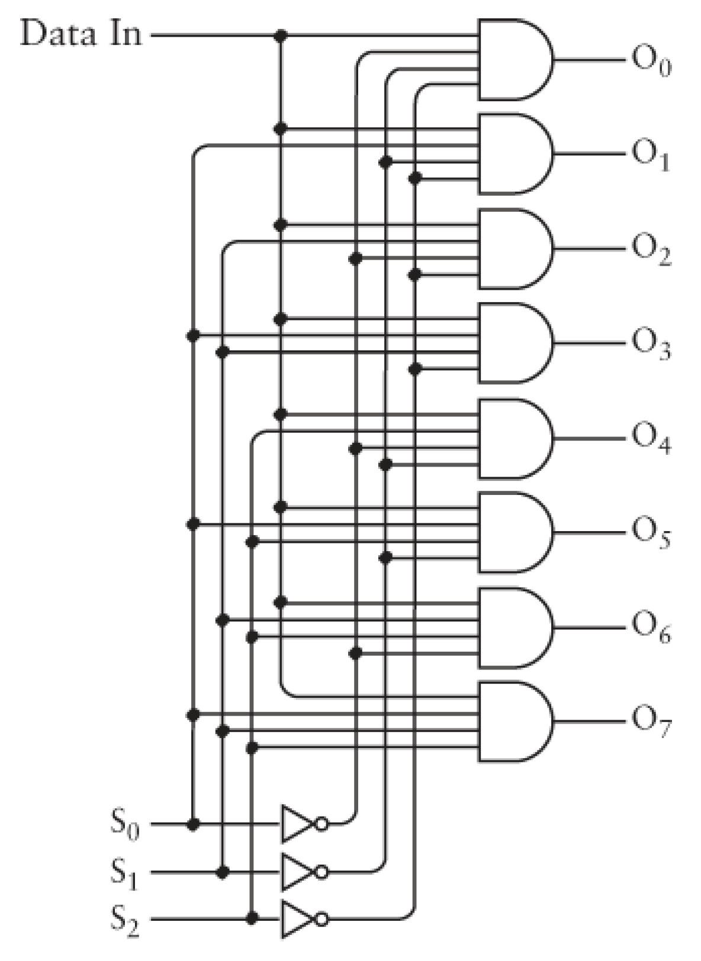

|  |
| --- |
| 1. What is the representation of the (decimal) number –1 in 4 bit 1’s complement format? [2 points] |

|  |  |
| --- | --- |
| **A.** | 1001 |

|  |  |
| --- | --- |
| **B.** | 1011 |

|  |  |
| --- | --- |
| **C.** | 1111 |

|  |  |
| --- | --- |
| **D.** | 1110 |

|  |  |
| --- | --- |
| **E.** | 0001 |

1. Please translate the following ASCII representation[2 points]



1. [How many significant digits do 32-bits float and 64-bits double have respectively?](http://stackoverflow.com/questions/13542944/how-many-significant-digits-have-floats-and-doubles-in-java) [2 points]
2. If a single pixel requires 36 bits, 24 bits for RGB information and 12 bits for color depth information, then how much bandwidth do you need to stream uncompressed 4K video in 24 fps rate? [2 points]